Week 2 Assignment: Text Markup and Links: Adding Pages to Your Site
Christian Alvarez
IT3240: Web Development and JavaScript
Professor Brad Brekland
April 26, 2026

Browser Testing and Html Validation
Browser Testing
The index.html, about.html, and contact.html file(s) were tested in two browsers to verify correct rendering: Google Chrome and Mozilla Firefox. Both browsers displayed the page(s) as expected, with all headings, images, paragraph text, and CSS styling rendering correctly.
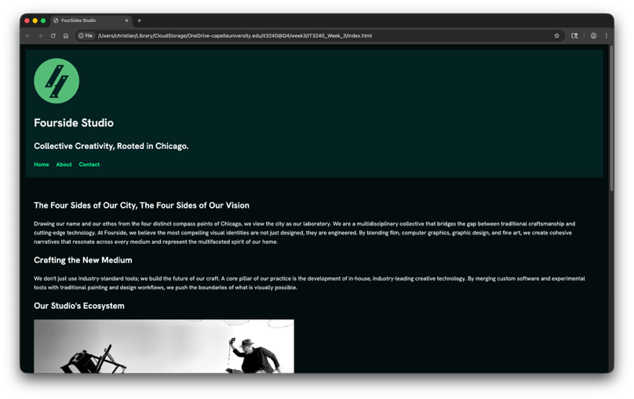(1.a index.html)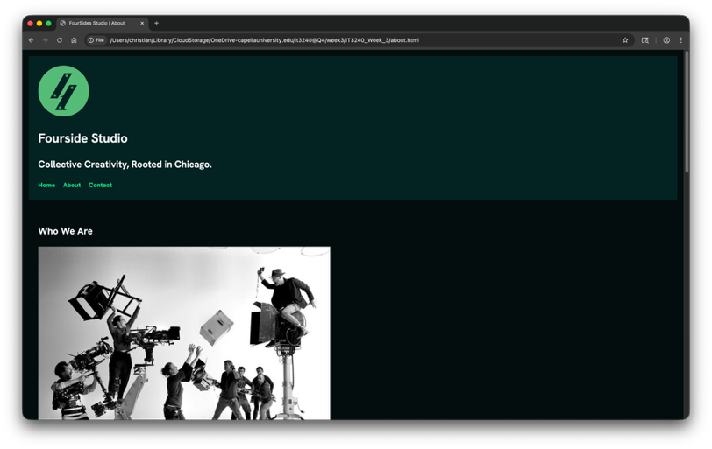(1.b about.html)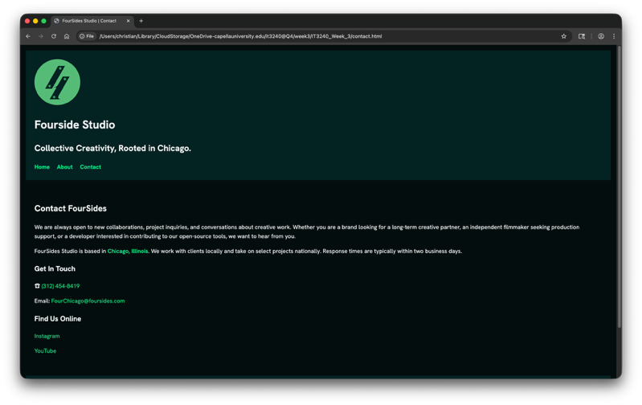(1.c contact.html)
Figure 1.a – 1.c Google Chrome render of the web page(s)
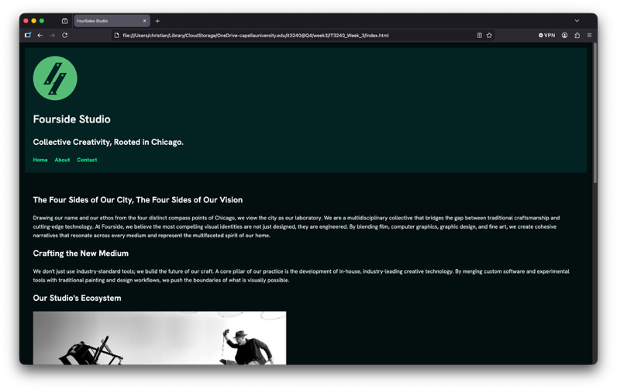(2.a index.html)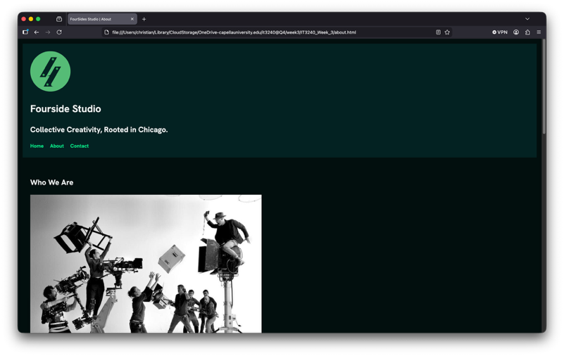(2.b about.html)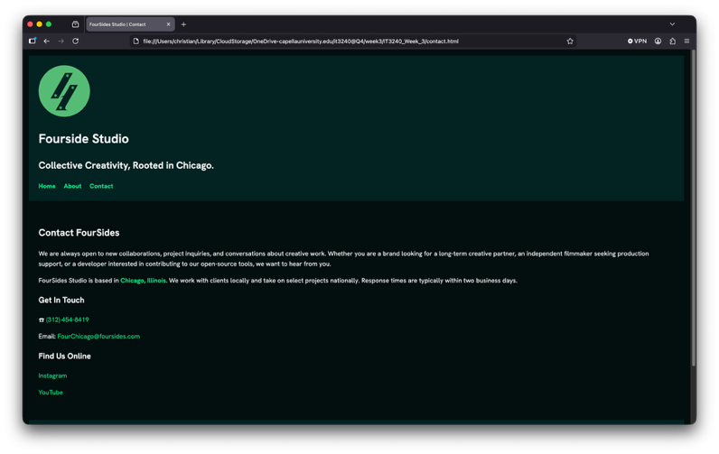(2.c contact.html)
Figure 2.a – 2.c Firefox render of the web page(s)

HTML Validation
The index.html, about.html, and contact.html files were validated using the Nu HTML Checker (validator.nu). All errors and warnings were identified and corrected prior to final submission. The validator returned no errors on the final check.
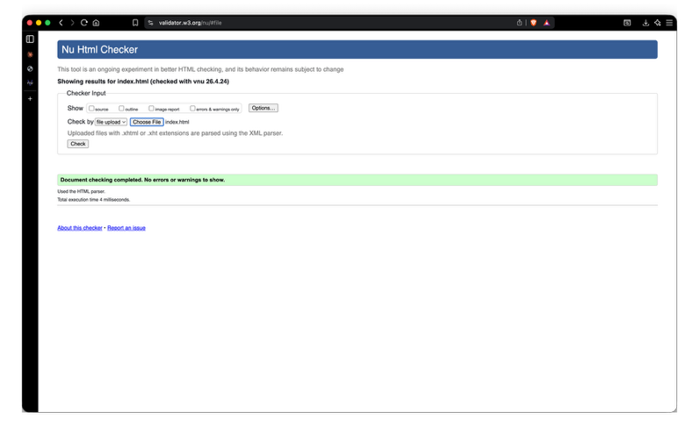(3.a index.html)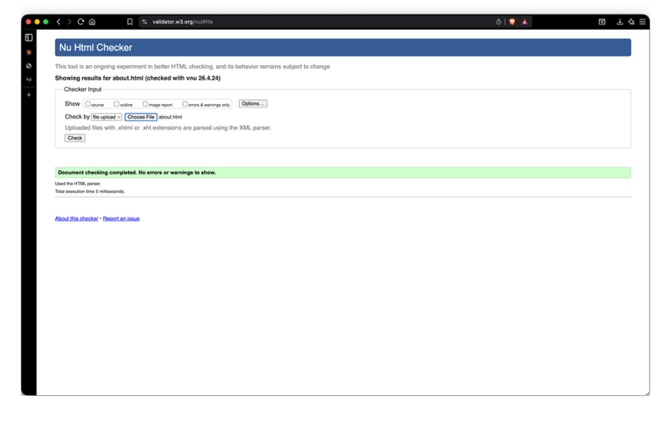(3.b about.html)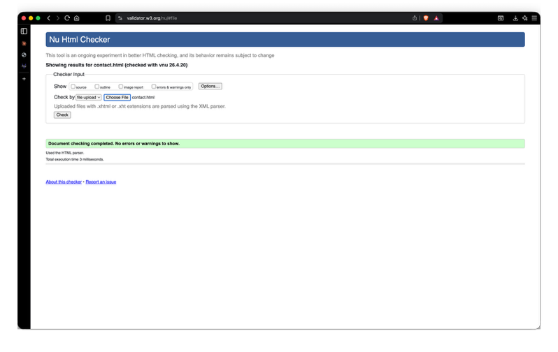(3.c contact.html)
Figure 3.a – 3.c Nu HTML Checker showing valid Html in the web page(s)
CSS Validation
The styles.css file was validated using the W3C CSS Validation Service (jigsaw.w3.org). The validator returned no errors on the final check. One warning was present: “Imported style sheets are not checked in direct input and file upload modes.” This is expected behavior when using @import for Google Fonts and does not indicate an error in the stylesheet.
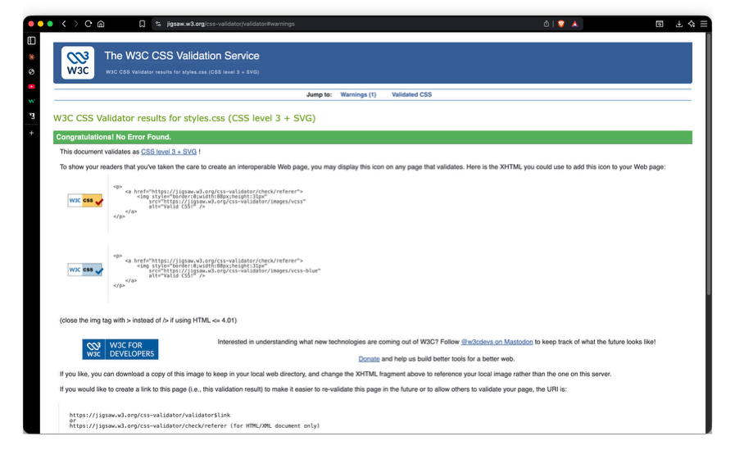
Figure 4. styles.css validated in w3

